How to Mark a 4BBB MiScore Card
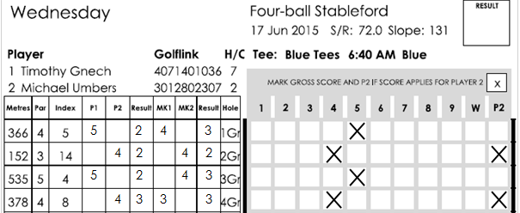
- Fill out the card as per normal in the Player, Result, Marker and Result columns.
- Place a circle in box that corresponds to the GROSS score achieved on the hole.
- If Player 2 has achieved the score on the hole place an extra circle in the P2 column.
- For holes you do not score on put a circle in the W column. This stands for wipe and will result in 0 points in Stableford or a – in Par events.
- Player and Marker sign in the area provided on the front of the card.

How to Mark a 4BBB MiScore Card
- Fill out the card as per normal in the Player, Result, Marker and Result columns.
- Place a circle in box that corresponds to the GROSS score achieved on the hole.
- If Player 2 has achieved the score on the hole place an extra circle in the P2 column.
- For holes you do not score on put a circle in the W column. This stands for wipe and will result in 0 points in Stableford or a – in Par events.
- Player and Marker sign in the area provided on the front of the card.

