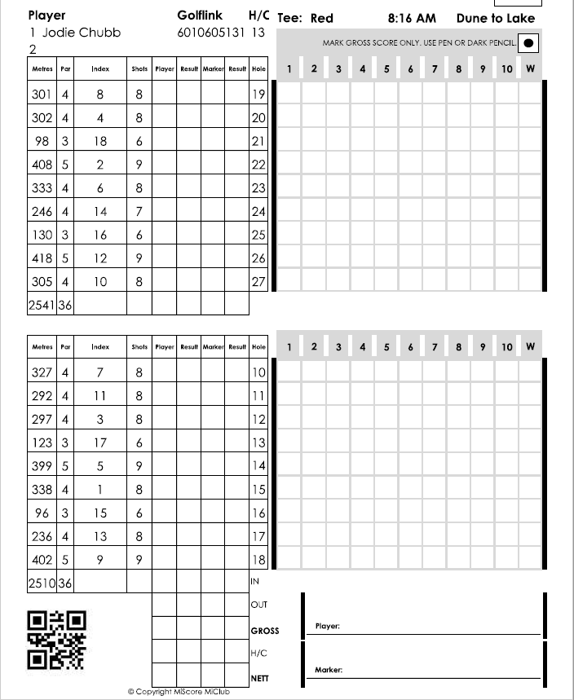

**Please make sure you are aware of your maximum score on each hole.**

**ALWAYS PICK UP WHEN YOU HAVE REACHED YOUR MAXIMUM SCORE!**

**The maximum score for each hole is displayed in the ‘shots’ column. The maximum score is determined by the par, index and players handicap.**

**On a par four, player A with a 36 handicap has a maximum score of 9. Player B with a scratch handicap has a maximum score of 7.**

**Maximum Score is a new form of Stroke play where a player’s score for each hole is capped at maximum of +3 on Nett Par. A player who does not complete a hole will NOT be disqualified, but simply gets the maximum score for the hole.**

Maximum Score Competition Type